MEETING DATE: | September 5, 2023 | ITEM NUMBER: 6.{{item.number}}

SECOND READING: |  | {{customfields.ResoOrdNumber}}
TYPE OF ITEM:
PRESENTED BY:
Harold Dominguez, City Manager's Office, Harold.Dominguez@longmontcolorado.gov
Jim Golden, Finance Administration, Jim.Golden@longmontcolorado.gov
Teresa Molloy, Budget, Teresa.Molloy@longmontcolorado.gov
Other City Staff

SUBJECT/AGENDA TITLE:
2024 Proposed Budget Presentation

EXECUTIVE SUMMARY:
The Proposed 2024 Budget presentation will focus on the categories of the 2024-2028 Capital Improvement Program (CIP), the Transportation (Street) Fund, and the Affordable Housing and Attainable Housing Funds. This information will be available on the City’s website with the 2024 proposed budget documents should we need to refer back to any information from this communication as we continue to move through the weekly 2024 budget presentations.

Link to all the budget documents:
2024 Budget Documents

COUNCIL OPTIONS:
Click or tap here to enter text.

RECOMMENDED OPTIONS:

FISCAL IMPACT & FUND SOURCE FOR RECOMMENDED ACTION:

BACKGROUND AND ISSUE ANALYSIS:
Citizens wishing to view the 2024 Proposed Budget, the 2024-2028 Proposed Capital Improvement Program or the 2024 Proposed Pay Plan can access these documents on the City’s website at the following location: 2024 Budget Documents

2024-2028 CAPITAL IMPROVEMENT PROGRAM (CIP)
For the five-year period from 2024-2028, $267,329,896 of capital projects are proposed to be funded. Of that amount, projects totaling $63,043,323 are planned for 2024 and are included in the proposed 2024 Operating Budget. By category, the projects proposed to be funded for 2024 are:

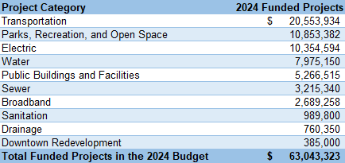

Staff will be presenting on several select projects that are underway in 2023 as well as select projects that are proposed for funding in 2024. Should Council have questions on any projects included in the Proposed 2024-2028 Capital Improvement Program, staff will be available.

TRANSPORTATION (STREET) FUND
The 2024 proposed budget for the Street Fund includes $29,807,163 in revenues (including $2.099 m to support TRP137 and TRP011), $31,192,272 in expenses and will require a contribution of $1,385,109 in fund balance. For 2024 there are 42.913 FTE in this fund, including 4.94 new FTE.

Vision Zero support in this proposed budget includes four new positions: an Alternative Transportation Planner; a Sr GIS Mapping Technician; a Neighborhood Resource Specialist; and a Transportation Engineering Assistant. There is also $150,000 for consulting work and $400,000 imbedded in TRP011 for capital improvements.

This proposed 2024 budget includes $183,700 for the FLEX bus program providing bus service between Longmont and Fort Collins. Additionally, VIA is again funded at $150,000, and RideFree Longmont (plus pay-as-you-go Access-a-Ride payments) is funded at $224,000, and $648,060 of new funding was requested to support the creation and operation of the Micro Transit System. Total transit program funding in the proposed 2024 budget is $1,205,760.

There is a total of $15,613,258 in 11 different CIP projects proposed to be funded from the Street Fund as shown below:

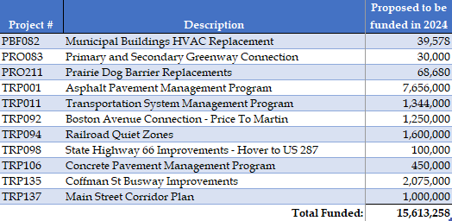

AFFORDABLE AND ATTAINABLE HOUSING FUNDS
The 2024 proposed budget for the Affordable Housing Fund totals $2,836,543. This includes a transfer from the General Fund of $1,206,543, consistent with prior year budgets. Beginning in 2019, affordable housing development was boosted by 50% of the 3% special sales tax on the sale of marijuana. This revenue is estimated at $275,000 for 2024. This fund also includes $1,355,000 of program income and fee in lieu revenue. There are 3.34 FTE proposed to be funded in this fund.

The proposed budget includes a $1,000,000 transfer from the General Fund to the Attainable Housing Fund, $600,000 ongoing ($350,000 more than 2023) and $400,000 one time. There are 1.6 FTE proposed to be funded in this fund, which includes one new full-time Homeownership Specialist. This new position is requested to bolster existing programs, like the Down Payment Assistance Program, and also allow the City to create new programs and initiatives, including efforts to increase the building and financing of affordable/attainable for-sale development projects.

The amount of total Affordable Housing Fund and Attainable Housing Fund revenues allowed to be used to administer the program is proposed to be increased from 10% to 20% for 2024. Historically, federal CDBG funds have covered more administrative costs of the Housing & Community Investment Division, but those sources have consistently decreased over time. Additionally, many administrative costs were split with the former Community Services Administration budget, but with organizational realignment, it makes more sense to separate the budget from the new Human Services Department. Due to the wide range of new affordable housing funding sources at the federal and state level, the City needs more capacity to go after those sources and administer them once received. Most of these sources do not come with an administrative allowance. Additionally, the City has increased its production of affordable housing and is creating new programs to do the same for attainable housing, which also necessitates additional capacity. Attachment A outlines the staffing costs and the need for the increase to the administrative cap.

ATTACHMENTS:
Attachment A – Affordable and Attainable Administrative Caps

